## Output of Airline Pricing Analysis

### Pratyusha Maiti

#### Email: [pratyusha.maiti@gmail.com](mailto:pratyusha.maiti@gmail.com)

#### Jadavpur University

> library(psych)

> describe(airlines)

vars n mean sd median trimmed mad min max range skew kurtosis se

AIRLINE* 1 462 3.02 1.65 2.00 2.90 1.48 1.00 6.00 5.00 0.59 -0.95 0.08

AIRCRAFT 2 462 0.33 0.47 0.00 0.28 0.00 0.00 1.00 1.00 0.74 -1.46 0.02

FLIGHT_DURATION 3 462 7.55 3.54 7.75 7.54 4.82 1.25 14.66 13.41 -0.05 -1.12 0.16

MONTH 4 462 1.67 1.05 2.00 1.71 1.48 0.00 3.00 3.00 -0.16 -1.20 0.05

INTERNATIONAL 5 462 0.91 0.28 1.00 1.00 0.00 0.00 1.00 1.00 -2.93 6.60 0.01

SEATS_ECONOMY 6 462 200.71 77.96 185.00 193.76 85.99 17.00 389.00 372.00 0.61 -0.26 3.63

SEATS_PREMIUM 7 462 33.54 13.26 36.00 33.20 11.86 8.00 66.00 58.00 0.25 -0.46 0.62

PITCH_ECONOMY 8 462 31.21 0.66 31.00 31.25 0.00 30.00 33.00 3.00 -0.03 -0.38 0.03

PITCH_PREMIUM 9 462 37.92 1.32 38.00 38.06 0.00 34.00 40.00 6.00 -1.48 3.43 0.06

WIDTH_ECONOMY 10 462 17.83 0.56 18.00 17.81 0.00 17.00 19.00 2.00 -0.03 -0.12 0.03

WIDTH_PREMIUM 11 462 19.48 1.10 19.00 19.54 0.00 17.00 21.00 4.00 -0.09 -0.34 0.05

PRICE_ECONOMY 12 462 1317.06 989.81 1224.00 1231.30 1163.84 65.00 3593.00 3528.00 0.52 -0.88 46.05

PRICE_PREMIUM 13 462 1832.35 1289.97 1710.00 1782.94 1852.51 86.00 7414.00 7328.00 0.51 0.41 60.01

PRICE_RELATIVE 14 462 0.49 0.45 0.38 0.43 0.42 0.02 1.89 1.87 1.14 0.61 0.02

N 15 462 234.25 86.88 227.00 227.69 90.44 38.00 441.00 403.00 0.61 -0.44 4.04

LAMBDA 16 462 0.15 0.06 0.13 0.14 0.03 0.05 0.55 0.50 2.70 14.02 0.00

QUALITY 17 462 6.72 1.78 7.00 6.79 0.00 2.00 10.00 8.00 -0.51 1.67 0.08

> par(mfrow = c(3,2))

> boxplot(airlines$PRICE_PREMIUM, horizontal = TRUE, xlab = "Premium price")

> boxplot(airlines$PRICE_ECONOMY, horizontal = TRUE, xlab = "Economy price")

> boxplot(airlines$WIDTH_PREMIUM, horizontal = TRUE, xlab = "Width of premium seats")

> boxplot(airlines$WIDTH_ECONOMY, horizontal = TRUE, xlab = "Width of economy seats")

> boxplot(airlines$PITCH_PREMIUM, horizontal = TRUE, xlab = "Pitch of premium seats")

> boxplot(airlines$PITCH_ECONOMY, horizontal = TRUE, xlab = "Pitch of economy seats")

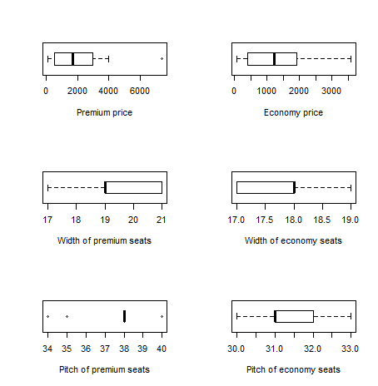

> library(ggplot2)

> ggplot(airlines, aes(x = PRICE_ECONOMY, fill = SEATS_ECONOMY)) + geom_histogram(binwidth = 50)

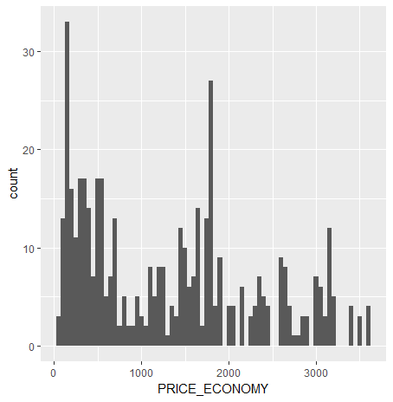

> ggplot(airlines, aes(x = PRICE_PREMIUM, fill = SEATS_PREMIUM)) + geom_histogram(binwidth = 50)

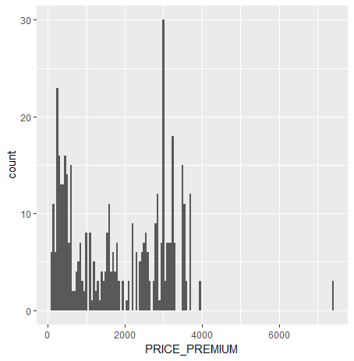

> qplot(FLIGHT_DURATION,PRICE_ECONOMY,

+ main="Price of economy seats vs flight hours",

+ xlab="Hours", ylab="Price",

+ color = AIRLINE)

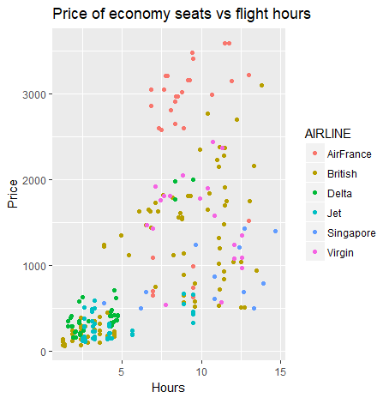

> qplot(FLIGHT_DURATION,PRICE_PREMIUM,

+ main="Price of premium seats vs flight hours",

+ xlab="Hours", ylab="Price",

+ color = AIRLINE)

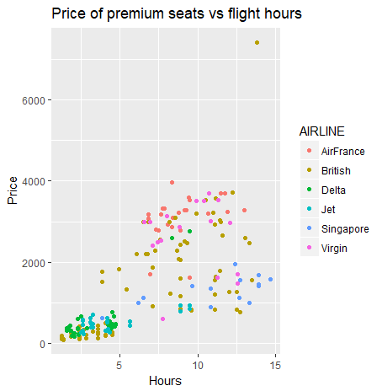

> plot(PRICE_PREMIUM,PRICE_ECONOMY,

+ col="blue",

+ main="Price of economy vs premium seats",

+ xlab="Premium Prices", ylab="Economy Prices")

> abline(h=mean(PRICE_ECONOMY), col="dark blue", lty="dotted")

> abline(v=mean(PRICE_PREMIUM), col="dark blue", lty="dotted")

> abline(lm(PRICE_ECONOMY~PRICE_PREMIUM))

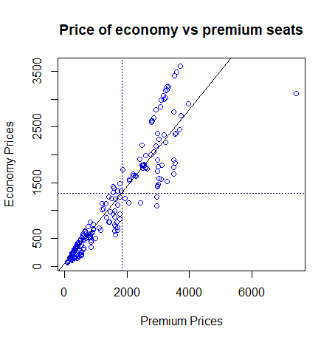

> library(car)

> scatterplotMatrix(formula = ~ SEATS_ECONOMY + PITCH_ECONOMY + WIDTH_ECONOMY + PRICE_ECONOMY, cex=0.6,

+ data=airlines, diagonal="density")

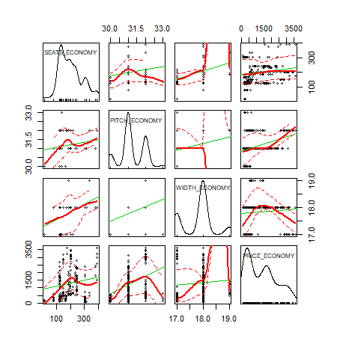

> scatterplotMatrix(formula = ~ SEATS_PREMIUM + PITCH_PREMIUM + WIDTH_PREMIUM + PRICE_PREMIUM, cex=0.6,

+ data=airlines, diagonal="density")

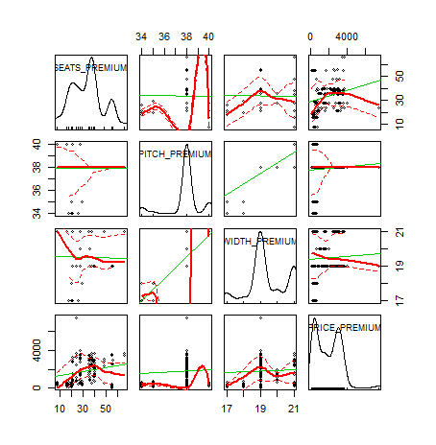

> library(corrplot)

> library(gplots)

> economy <- cor(airlines[,c(2:6,8,10,12,15,17)], use="complete.obs")

> corrplot.mixed(economy,

+ upper = "circle",

+ lower = "ellipse",

+ col = colorpanel(50, "red", "orange", "royalblue"),

+ tl.pos="lt")

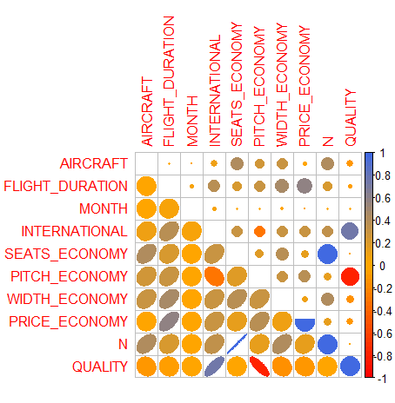

> premium <- cor(airlines[, c(2:5,7,9,11,13,15,17)], use="complete.obs")

> corrplot.mixed(premium,

+ upper = "circle",

+ lower = "ellipse",

+ col = colorpanel(50, "red", "orange", "royalblue"),

+ tl.pos="lt")

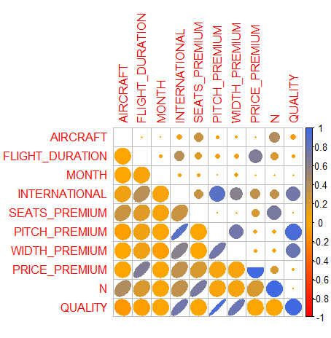

> cov_airlines <- airlines[-c(1)]

> var(cov_airlines)

AIRCRAFT FLIGHT_DURATION MONTH INTERNATIONAL SEATS_ECONOMY SEATS_PREMIUM PITCH_ECONOMY

AIRCRAFT 0.220492812 -3.701285e-02 0.003643500 1.534402e-02 14.6965800 1.83864834 0.075104938

FLIGHT_DURATION -0.037012846 1.253262e+01 0.159093163 3.690261e-01 57.7648124 7.87007057 0.710701749

MONTH 0.003643500 1.590932e-01 1.106271892 1.266774e-02 1.1205736 0.75688086 0.014282897

INTERNATIONAL 0.015344020 3.690261e-01 0.012667737 7.925552e-02 6.7555568 1.15305519 -0.053553821

SEATS_ECONOMY 14.696579993 5.776481e+01 1.120573570 6.755557e+00 6077.6910021 647.73917514 9.091218976

SEATS_PREMIUM 1.838648336 7.870071e+00 0.756880863 1.153055e+00 647.7391751 175.71539848 -0.162126377

PITCH_ECONOMY 0.075104938 7.107017e-01 0.014282897 -5.355382e-02 9.0912190 -0.16212638 0.438290560

PITCH_PREMIUM -0.025077237 3.839608e-01 -0.011963452 3.209755e-01 8.5222836 -0.14346283 -0.491816210

WIDTH_ECONOMY 0.076992422 9.176009e-01 0.020255233 4.608840e-02 17.1089106 3.43175480 0.115418204

WIDTH_PREMIUM 0.019062644 3.547466e-01 -0.076579241 1.895747e-01 6.0725695 -0.20548215 -0.400315520

PRICE_ECONOMY 17.323632983 1.999429e+03 3.101670564 8.333535e+01 11433.0342001 1602.26644505 248.750035214

PRICE_PREMIUM 12.170728043 2.976982e+03 25.684686969 1.255051e+02 19639.2185537 3847.35524129 204.823759754

PRICE_RELATIVE -0.025507038 1.735896e-01 0.009525782 3.539182e-02 -0.8657126 -0.64405105 -0.130376370

N 16.535228329 6.563488e+01 1.877454433 7.908612e+00 6725.4301772 823.45457363 8.929092599

LAMBDA -0.003692613 7.567372e-04 0.002478613 3.120451e-04 -1.9029572 0.25651576 -0.006991858

QUALITY -0.100182175 -3.267410e-01 -0.026246349 3.745293e-01 -0.5689354 0.01866355 -0.930106770

PITCH_PREMIUM WIDTH_ECONOMY WIDTH_PREMIUM PRICE_ECONOMY PRICE_PREMIUM PRICE_RELATIVE N

AIRCRAFT -0.025077237 0.076992422 0.019062644 1.732363e+01 1.217073e+01 -2.550704e-02 16.5352283

FLIGHT_DURATION 0.383960757 0.917600924 0.354746598 1.999429e+03 2.976982e+03 1.735896e-01 65.6348829

MONTH -0.011963452 0.020255233 -0.076579241 3.101671e+00 2.568469e+01 9.525782e-03 1.8774544

INTERNATIONAL 0.320975481 0.046088402 0.189574706 8.333535e+01 1.255051e+02 3.539182e-02 7.9086120

SEATS_ECONOMY 8.522283573 17.108910612 6.072569513 1.143303e+04 1.963922e+04 -8.657126e-01 6725.4301772

SEATS_PREMIUM -0.143462828 3.431754796 -0.205482153 1.602266e+03 3.847355e+03 -6.440510e-01 823.4545736

PITCH_ECONOMY -0.491816210 0.115418204 -0.400315520 2.487500e+02 2.048238e+02 -1.303764e-01 8.9290926

PITCH_PREMIUM 1.749129034 -0.032340761 1.099717347 4.403096e+01 1.216944e+02 2.563610e-01 8.3788207

WIDTH_ECONOMY -0.032340761 0.314167394 0.038651154 4.547520e+01 1.179328e+02 -1.547511e-02 20.5406654

WIDTH_PREMIUM 1.099717347 0.038651154 1.213435877 -7.651962e+01 7.008986e+01 2.553763e-01 5.8670874

PRICE_ECONOMY 44.030960363 45.475195087 -76.519621376 9.797165e+05 1.152371e+06 -1.336887e+02 13035.3006451

PRICE_PREMIUM 121.694406100 117.932783052 70.089857359 1.152371e+06 1.664025e+06 1.027099e+01 23486.5737950

PRICE_RELATIVE 0.256361007 -0.015475111 0.255376323 -1.336887e+02 1.027099e+01 2.052828e-01 -1.5097636

N 8.378820745 20.540665408 5.867087359 1.303530e+04 2.348657e+04 -1.509764e+00 7548.8847508

LAMBDA -0.004355485 0.003334085 -0.004853744 -3.434499e-01 2.801268e+00 -1.387251e-03 -1.6464414

QUALITY 2.240945244 -0.147758966 1.500032867 -2.047191e+02 -8.312935e+01 3.867374e-01 -0.5502719

LAMBDA QUALITY

AIRCRAFT -0.0036926125 -1.001822e-01

FLIGHT_DURATION 0.0007567372 -3.267410e-01

MONTH 0.0024786132 -2.624635e-02

INTERNATIONAL 0.0003120451 3.745293e-01

SEATS_ECONOMY -1.9029571513 -5.689354e-01

SEATS_PREMIUM 0.2565157619 1.866355e-02

PITCH_ECONOMY -0.0069918585 -9.301068e-01

PITCH_PREMIUM -0.0043554854 2.240945e+00

WIDTH_ECONOMY 0.0033340846 -1.477590e-01

WIDTH_PREMIUM -0.0048537435 1.500033e+00

PRICE_ECONOMY -0.3434498690 -2.047191e+02

PRICE_PREMIUM 2.8012680884 -8.312935e+01

PRICE_RELATIVE -0.0013872506 3.867374e-01

N -1.6464413894 -5.502719e-01

LAMBDA 0.0037413115 2.636373e-03

QUALITY 0.0026363730 3.171052e+00

> cov(cov_airlines)

AIRCRAFT FLIGHT_DURATION MONTH INTERNATIONAL SEATS_ECONOMY SEATS_PREMIUM PITCH_ECONOMY

AIRCRAFT 0.220492812 -3.701285e-02 0.003643500 1.534402e-02 14.6965800 1.83864834 0.075104938

FLIGHT_DURATION -0.037012846 1.253262e+01 0.159093163 3.690261e-01 57.7648124 7.87007057 0.710701749

MONTH 0.003643500 1.590932e-01 1.106271892 1.266774e-02 1.1205736 0.75688086 0.014282897

INTERNATIONAL 0.015344020 3.690261e-01 0.012667737 7.925552e-02 6.7555568 1.15305519 -0.053553821

SEATS_ECONOMY 14.696579993 5.776481e+01 1.120573570 6.755557e+00 6077.6910021 647.73917514 9.091218976

SEATS_PREMIUM 1.838648336 7.870071e+00 0.756880863 1.153055e+00 647.7391751 175.71539848 -0.162126377

PITCH_ECONOMY 0.075104938 7.107017e-01 0.014282897 -5.355382e-02 9.0912190 -0.16212638 0.438290560

PITCH_PREMIUM -0.025077237 3.839608e-01 -0.011963452 3.209755e-01 8.5222836 -0.14346283 -0.491816210

WIDTH_ECONOMY 0.076992422 9.176009e-01 0.020255233 4.608840e-02 17.1089106 3.43175480 0.115418204

WIDTH_PREMIUM 0.019062644 3.547466e-01 -0.076579241 1.895747e-01 6.0725695 -0.20548215 -0.400315520

PRICE_ECONOMY 17.323632983 1.999429e+03 3.101670564 8.333535e+01 11433.0342001 1602.26644505 248.750035214

PRICE_PREMIUM 12.170728043 2.976982e+03 25.684686969 1.255051e+02 19639.2185537 3847.35524129 204.823759754

PRICE_RELATIVE -0.025507038 1.735896e-01 0.009525782 3.539182e-02 -0.8657126 -0.64405105 -0.130376370

N 16.535228329 6.563488e+01 1.877454433 7.908612e+00 6725.4301772 823.45457363 8.929092599

LAMBDA -0.003692613 7.567372e-04 0.002478613 3.120451e-04 -1.9029572 0.25651576 -0.006991858

QUALITY -0.100182175 -3.267410e-01 -0.026246349 3.745293e-01 -0.5689354 0.01866355 -0.930106770

PITCH_PREMIUM WIDTH_ECONOMY WIDTH_PREMIUM PRICE_ECONOMY PRICE_PREMIUM PRICE_RELATIVE N

AIRCRAFT -0.025077237 0.076992422 0.019062644 1.732363e+01 1.217073e+01 -2.550704e-02 16.5352283

FLIGHT_DURATION 0.383960757 0.917600924 0.354746598 1.999429e+03 2.976982e+03 1.735896e-01 65.6348829

MONTH -0.011963452 0.020255233 -0.076579241 3.101671e+00 2.568469e+01 9.525782e-03 1.8774544

INTERNATIONAL 0.320975481 0.046088402 0.189574706 8.333535e+01 1.255051e+02 3.539182e-02 7.9086120

SEATS_ECONOMY 8.522283573 17.108910612 6.072569513 1.143303e+04 1.963922e+04 -8.657126e-01 6725.4301772

SEATS_PREMIUM -0.143462828 3.431754796 -0.205482153 1.602266e+03 3.847355e+03 -6.440510e-01 823.4545736

PITCH_ECONOMY -0.491816210 0.115418204 -0.400315520 2.487500e+02 2.048238e+02 -1.303764e-01 8.9290926

PITCH_PREMIUM 1.749129034 -0.032340761 1.099717347 4.403096e+01 1.216944e+02 2.563610e-01 8.3788207

WIDTH_ECONOMY -0.032340761 0.314167394 0.038651154 4.547520e+01 1.179328e+02 -1.547511e-02 20.5406654

WIDTH_PREMIUM 1.099717347 0.038651154 1.213435877 -7.651962e+01 7.008986e+01 2.553763e-01 5.8670874

PRICE_ECONOMY 44.030960363 45.475195087 -76.519621376 9.797165e+05 1.152371e+06 -1.336887e+02 13035.3006451

PRICE_PREMIUM 121.694406100 117.932783052 70.089857359 1.152371e+06 1.664025e+06 1.027099e+01 23486.5737950

PRICE_RELATIVE 0.256361007 -0.015475111 0.255376323 -1.336887e+02 1.027099e+01 2.052828e-01 -1.5097636

N 8.378820745 20.540665408 5.867087359 1.303530e+04 2.348657e+04 -1.509764e+00 7548.8847508

LAMBDA -0.004355485 0.003334085 -0.004853744 -3.434499e-01 2.801268e+00 -1.387251e-03 -1.6464414

QUALITY 2.240945244 -0.147758966 1.500032867 -2.047191e+02 -8.312935e+01 3.867374e-01 -0.5502719

LAMBDA QUALITY

AIRCRAFT -0.0036926125 -1.001822e-01

FLIGHT_DURATION 0.0007567372 -3.267410e-01

MONTH 0.0024786132 -2.624635e-02

INTERNATIONAL 0.0003120451 3.745293e-01

SEATS_ECONOMY -1.9029571513 -5.689354e-01

SEATS_PREMIUM 0.2565157619 1.866355e-02

PITCH_ECONOMY -0.0069918585 -9.301068e-01

PITCH_PREMIUM -0.0043554854 2.240945e+00

WIDTH_ECONOMY 0.0033340846 -1.477590e-01

WIDTH_PREMIUM -0.0048537435 1.500033e+00

PRICE_ECONOMY -0.3434498690 -2.047191e+02

PRICE_PREMIUM 2.8012680884 -8.312935e+01

PRICE_RELATIVE -0.0013872506 3.867374e-01

N -1.6464413894 -5.502719e-01

LAMBDA 0.0037413115 2.636373e-03

QUALITY 0.0026363730 3.171052e+00

> cor.test(PRICE_ECONOMY,SEATS_ECONOMY+PITCH_ECONOMY+WIDTH_ECONOMY, data = airlines)

Pearson's product-moment correlation

data: PRICE_ECONOMY and SEATS_ECONOMY + PITCH_ECONOMY + WIDTH_ECONOMY

t = 3.2831, df = 460, p-value = 0.001105

alternative hypothesis: true correlation is not equal to 0

95 percent confidence interval:

0.06092573 0.23924003

sample estimates:

cor

0.1513136

> cor.test(PRICE_ECONOMY,PITCH_ECONOMY+WIDTH_ECONOMY, data = airlines)

Pearson's product-moment correlation

data: PRICE_ECONOMY and PITCH_ECONOMY + WIDTH_ECONOMY

t = 6.7393, df = 460, p-value = 4.777e-11

alternative hypothesis: true correlation is not equal to 0

95 percent confidence interval:

0.2144044 0.3805905

sample estimates:

cor

0.2997698

> cor.test(PRICE_PREMIUM,SEATS_PREMIUM+PITCH_PREMIUM+WIDTH_PREMIUM, data = airlines)

Pearson's product-moment correlation

data: PRICE_PREMIUM and SEATS_PREMIUM + PITCH_PREMIUM + WIDTH_PREMIUM

t = 5.145, df = 460, p-value = 3.969e-07

alternative hypothesis: true correlation is not equal to 0

95 percent confidence interval:

0.1451281 0.3177358

sample estimates:

cor

0.2332686

> cor.test(PRICE_PREMIUM,PITCH_PREMIUM+WIDTH_PREMIUM, data = airlines)

Pearson's product-moment correlation

data: PRICE_PREMIUM and PITCH_PREMIUM + WIDTH_PREMIUM

t = 1.4065, df = 460, p-value = 0.1603

alternative hypothesis: true correlation is not equal to 0

95 percent confidence interval:

-0.02594671 0.15573632

sample estimates:

cor

0.06543711

> regression_economy<-lm(PRICE_ECONOMY~FLIGHT_DURATION+SEATS_PREMIUM+PITCH_PREMIUM+WIDTH_PREMIUM+QUALITY+MONTH+AIRCRAFT+AIRLINE,

+ data=airlines)

> summary(regression_economy)

Call:

lm(formula = PRICE_ECONOMY ~ FLIGHT_DURATION + SEATS_PREMIUM +

PITCH_PREMIUM + WIDTH_PREMIUM + QUALITY + MONTH + AIRCRAFT +

AIRLINE, data = airlines)

Residuals:

Min 1Q Median 3Q Max

-2032.41 -260.37 87.17 348.87 1183.81

Coefficients:

Estimate Std. Error t value Pr(>|t|)

(Intercept) -10826.252 4875.591 -2.221 0.026883 *

FLIGHT_DURATION 105.107 9.410 11.170 < 2e-16 ***

SEATS_PREMIUM 1.095 3.393 0.323 0.747006

PITCH_PREMIUM 205.595 154.269 1.333 0.183305

WIDTH_PREMIUM 330.060 224.231 1.472 0.141731

QUALITY -216.789 144.045 -1.505 0.133025

MONTH -33.857 23.496 -1.441 0.150292

AIRCRAFT -214.313 61.901 -3.462 0.000587 ***

AIRLINEBritish -1200.140 172.587 -6.954 1.26e-11 ***

AIRLINEDelta -1308.049 360.447 -3.629 0.000317 ***

AIRLINEJet -2249.411 194.831 -11.545 < 2e-16 ***

AIRLINESingapore -2423.334 244.361 -9.917 < 2e-16 ***

AIRLINEVirgin -1648.955 364.367 -4.526 7.72e-06 ***

---

Signif. codes: 0 ‘***’ 0.001 ‘**’ 0.01 ‘*’ 0.05 ‘.’ 0.1 ‘ ’ 1

Residual standard error: 525.8 on 449 degrees of freedom

Multiple R-squared: 0.7251, Adjusted R-squared: 0.7178

F-statistic: 98.71 on 12 and 449 DF, p-value: < 2.2e-16

> fitted(regression_economy)

1 2 3 4 5 6 7 8 9 10

2641.636489 2607.779970 2662.409435 2675.493009 2696.265954 3082.760554 3048.904034 2730.122474 2709.349528 2829.126314

11 12 13 14 15 16 17 18 19 20

2795.269795 2761.413276 2641.003478 2607.146958 2573.290439 2539.433920 2641.003478 2607.146958 2573.290439 2539.433920

21 22 23 24 25 26 27 28 29 30

2502.039680 2468.183161 2434.326642 2538.527044 2504.670525 2674.174235 2415.629522 2381.773003 2671.465397 2907.127890

31 32 33 34 35 36 37 38 39 40

2873.271371 2839.414852 3084.978699 3051.122180 3017.265661 2668.109180 2634.252660 2600.396141 2758.704438 2637.608878

41 42 43 44 45 46 47 48 49 50

2603.752359 2668.031186 2643.634322 2609.777803 2790.233940 2547.013620 2985.958349 2952.101829 2918.245310 2884.388791

51 52 53 54 55 56 57 58 59 60

2797.639641 2763.783122 2729.926603 2704.478666 2730.344664 2696.488145 2669.989135 2636.132616 2728.242518 2694.385999

61 62 63 64 65 66 67 68 69 70

2669.989135 2636.132616 2942.642174 2908.785655 2874.929136 3218.068753 3184.212234 3139.412293 3105.555774 3239.266889

71 72 73 74 75 76 77 78 79 80

3205.410369 3171.553850 3137.697331 3150.473592 1985.906439 1952.049920 1918.193401 1871.217343 1837.360824 1803.504304

81 82 83 84 85 86 87 88 89 90

1769.647785 1558.766394 1524.909875 1491.053356 1457.196836 1489.395591 1455.539071 1421.682552 1387.826033 1639.582461

91 92 93 94 95 96 97 98 99 100

1571.869423 1605.725942 1701.595755 1667.739236 1633.882717 1620.885342 1587.028822 1553.172303 1519.315784 1447.236143

101 102 103 104 105 106 107 108 109 110

1413.379623 1379.523104 1778.546259 1744.689739 1710.833220 1676.976701 1407.472057 1373.615538 1339.759018 1232.993975

111 112 113 114 115 116 117 118 119 120

1199.137456 1164.185694 1724.673846 1690.817327 1758.530365 1792.386885 1319.059780 1285.203261 1251.346741 1217.490222

121 122 123 124 125 126 127 128 129 130

1713.290066 1679.433546 1645.577027 1766.938947 1733.082428 1699.225909 1726.715849 1692.859329 1659.002810 1364.033719

131 132 133 134 135 136 137 138 139 140

1330.177200 1296.320681 1397.890239 1512.579335 1478.722816 1444.866296 1526.066601 1492.210082 1458.353563 1933.352800

141 142 143 144 145 146 147 148 149 150

1899.496281 1865.639762 1448.065025 1455.644725 1421.788206 1387.931686 1307.443463 1273.586944 1239.730424 1187.753676

151 152 153 154 155 156 157 158 159 160

1153.897157 1120.040637 1259.270795 1225.414276 1191.557756 1249.811140 1215.954621 1182.098101 1469.485351 1435.628832

161 162 163 164 165 166 167 168 169 170

1401.772312 1481.921544 1289.575226 1255.718706 1221.862187 1065.873403 1032.016884 998.160365 1744.689739 1676.976701

171 172 173 174 175 176 177 178 179 180

1778.546259 1710.833220 986.214063 952.357543 918.501024 884.644505 1491.053356 1457.196836 1524.909875 1414.208506

181 182 183 184 185 186 187 188 189 190

1743.860857 1968.744921 1934.888402 1901.031883 986.214063 952.357543 918.501024 884.644505 1118.427042 1084.570523

191 192 193 194 195 196 197 198 199 200

1050.714004 1862.542400 1781.387606 1416.931712 1383.075193 1349.218673 1710.004338 1676.147818 1468.778632 1255.718706

201 202 203 204 205 206 207 208 209 210

1434.922112 1401.065593 1642.291299 1539.200508 1794.829362 1471.487469 1505.343989 1889.914463 1856.057943 1822.201424

211 212 213 214 215 216 217 218 219 220

746.893828 728.196708 694.340189 639.077712 693.511306 659.654787 728.196708 563.784974 605.221193 571.364673

221 222 223 224 225 226 227 228 229 230

605.221193 625.798268 578.115491 660.483669 824.895404 537.508154 757.182365 544.258971 639.077712 694.340189

231 232 233 234 235 236 237 238 239 240

780.750347 615.509730 791.038884 517.153270 713.037308 697.609407 571.364673 510.402452 476.545933 483.296750

241 242 243 244 245 246 247 248 249 250

449.440231 663.752888 660.483669 581.653211 706.017989 672.161470 629.896368 537.508154 638.304951 1761.047948

251 252 253 254 255 256 257 258 259 260

1693.334909 1884.023463 1850.166944 1816.310424 1727.191428 435.238053 398.228315 805.263944 505.882119 474.127746

261 262 263 264 265 266 267 268 269 270

441.322299 333.593228 265.880189 232.023670 443.646635 398.228315 417.147625 299.736709 824.183254 466.992427

271 272 273 274 275 276 277 278 279 280

447.850926 839.120463 509.610888 360.063102 -23.974562 351.217906 8.608694 213.019103 495.044799 345.740352

281 282 283 284 285 286 287 288 289 290

539.738639 527.628055 385.074425 278.249504 311.883832 858.039773 -38.689581 -70.443954 184.253849 523.645954

291 292 293 294 295 296 297 298 299 300

-73.597173 352.491169 218.110368 376.443653 410.300172 236.782325 202.925806 169.069286 270.638844 481.328923

301 302 303 304 305 306 307 308 309 310

252.417248 150.847690 169.069286 366.286467 264.716909 412.997952 515.185442 481.328923 447.472404 413.615885

311 312 313 314 315 316 317 318 319 320

324.021366 347.365817 313.509297 279.652778 191.808386 124.095347 90.238828 515.185442 208.625550 140.912512

321 322 323 324 325 326 327 328 329 330

107.055992 332.429948 218.560728 236.782325 290.164846 264.716909 480.710991 298.573429 514.567510 157.951867

331 332 333 334 335 336 337 338 339 340

174.769031 157.598507 123.741988 89.885468 384.154705 350.298185 316.441666 282.585147 184.704209 381.222336

341 342 343 344 345 346 347 348 349 350

191.455026 89.885468 202.925806 265.913520 232.057001 198.200481 164.343962 157.598507 123.741988 384.841177

351 352 353 354 355 356 357 358 359 360

350.984658 446.854471 418.697697 261.876903 232.057001 198.200481 164.343962 265.913520 270.638844 191.455026

361 362 363 364 365 366 367 368 369 370

1322.350641 1089.694224 1055.837705 1021.981185 988.124666 336.075041 302.218522 268.362002 234.505483 1288.494121

371 372 373 374 375 376 377 378 379 380

1254.637602 1356.207160 1019.272348 985.415828 951.559309 917.702790 371.811515 337.954996 304.098477 270.241957

381 382 383 384 385 386 387 388 389 390

1164.689724 1130.833204 1096.976685 1032.476744 998.620225 964.763705 1401.181099 1367.324580 1333.468061 875.644709

391 392 393 394 395 396 397 398 399 400

841.788190 807.931671 296.725798 262.869279 229.012760 195.156240 1200.426198 1166.569679 1132.713160 1234.282718

401 402 403 404 405 406 407 408 409 410

1971.938942 1938.082423 1904.225904 1870.369384 2025.321464 1991.464944 1957.608425 2059.177983 1304.746427 1270.889908

411 412 413 414 415 416 417 418 419 420

1237.033389 1203.176869 1270.061026 1236.204506 1202.347987 1168.491468 1865.047714 1831.191195 1797.334676 1763.478156

421 422 423 424 425 426 427 428 429 430

1927.793886 1893.937366 1860.080847 1826.224328 1672.621900 1638.765381 1604.908862 1782.079271 1430.265788 1396.409268

431 432 433 434 435 436 437 438 439 440

1362.552749 1328.696230 2077.875103 1953.337828 1919.481309 1885.624789 1851.768270 2010.162064 1735.464077 1701.607557

441 442 443 444 445 446 447 448 449 450

1878.777967 1357.300066 1323.443547 1289.587028 1255.730508 1594.603814 1560.747295 1526.890776 1493.034256 1517.504828

451 452 453 454 455 456 457 458 459 460

1483.648309 1449.791790 1415.935270 1322.614665 1299.710573 1265.854053 1231.997534 2044.018583 1393.036541 1370.132449

461 462

1325.323502 1291.466983

> coefficients(regression_economy)

(Intercept) FLIGHT_DURATION SEATS_PREMIUM PITCH_PREMIUM WIDTH_PREMIUM QUALITY MONTH

-10826.251742 105.107278 1.095243 205.595332 330.059654 -216.788648 -33.856519

AIRCRAFT AIRLINEBritish AIRLINEDelta AIRLINEJet AIRLINESingapore AIRLINEVirgin

-214.312657 -1200.140284 -1308.048797 -2249.411483 -2423.333939 -1648.954502

> regression_premium<-lm(PRICE_PREMIUM~FLIGHT_DURATION+SEATS_PREMIUM+PITCH_PREMIUM+WIDTH_PREMIUM+QUALITY+MONTH+AIRCRAFT+AIRLINE,

+ data=airlines)

> summary(regression_premium)

Call:

lm(formula = PRICE_PREMIUM ~ FLIGHT_DURATION + SEATS_PREMIUM +

PITCH_PREMIUM + WIDTH_PREMIUM + QUALITY + MONTH + AIRCRAFT +

AIRLINE, data = airlines)

Residuals:

Min 1Q Median 3Q Max

-2129.1 -399.4 71.1 365.1 4379.6

Coefficients:

Estimate Std. Error t value Pr(>|t|)

(Intercept) -12772.438 6979.988 -1.830 0.06793 .

FLIGHT_DURATION 180.016 13.471 13.363 < 2e-16 ***

SEATS_PREMIUM 0.475 4.858 0.098 0.92214

PITCH_PREMIUM 227.471 220.855 1.030 0.30358

WIDTH_PREMIUM 359.232 321.013 1.119 0.26371

QUALITY -183.785 206.217 -0.891 0.37329

MONTH -27.232 33.637 -0.810 0.41861

AIRCRAFT -234.475 88.618 -2.646 0.00843 **

AIRLINEBritish -795.263 247.079 -3.219 0.00138 **

AIRLINEDelta -908.418 516.023 -1.760 0.07902 .

AIRLINEJet -2198.677 278.923 -7.883 2.45e-14 ***

AIRLINESingapore -2478.352 349.832 -7.084 5.43e-12 ***

AIRLINEVirgin -925.614 521.634 -1.774 0.07667 .

---

Signif. codes: 0 ‘***’ 0.001 ‘**’ 0.01 ‘*’ 0.05 ‘.’ 0.1 ‘ ’ 1

Residual standard error: 752.8 on 449 degrees of freedom

Multiple R-squared: 0.6683, Adjusted R-squared: 0.6595

F-statistic: 75.39 on 12 and 449 DF, p-value: < 2.2e-16

> fitted(regression_premium)

1 2 3 4 5 6 7 8 9 10 11

2795.00347 2767.77169 2998.11334 2822.23526 3025.34513 3663.47677 3636.24499 3052.57691 2849.46704 3079.75817 3052.52639

12 13 14 15 16 17 18 19 20 21 22

3025.29461 2869.18989 2841.95811 2814.72632 2787.49454 2869.18989 2841.95811 2814.72632 2787.49454 2661.94203 2634.71025

23 24 25 26 27 28 29 30 31 32 33

2607.47847 2700.62016 2673.38838 2875.88127 2544.70222 2517.47043 2809.73407 3182.59671 3155.36492 3128.13314 3503.94585

34 35 36 37 38 39 40 41 42 43 44

3476.71407 3449.48229 2946.36743 2919.13564 2891.90386 2959.14740 2782.50228 2755.27050 2891.66657 2880.63623 2853.40445

45 46 47 48 49 50 51 52 53 54 55

3060.64757 2769.72231 3317.60876 3290.37698 3263.14519 3235.91341 3000.68054 2973.44876 2946.21697 2933.38648 3022.20355

56 57 58 59 60 61 62 63 64 65 66

2994.97177 2980.34111 2953.10933 3018.60323 2991.37145 2980.34111 2953.10933 3274.17553 3246.94375 3219.71196 3720.74483

67 68 69 70 71 72 73 74 75 76 77

3693.51304 3627.92757 3600.69579 3751.44749 3724.21571 3696.98392 3669.75214 3717.94034 3088.89856 3061.66678 3034.43500

78 79 80 81 82 83 84 85 86 87 88

2839.30533 2812.07354 2784.84176 2757.60998 2415.73825 2388.50647 2361.27469 2334.04291 2296.92765 2269.69586 2242.46408

89 90 91 92 93 94 95 96 97 98 99

2215.23230 2478.94388 2424.48031 2451.71210 2585.15336 2557.92158 2530.68980 2416.16763 2388.93584 2361.70406 2334.47228

100 101 102 103 104 105 106 107 108 109 110

2149.51447 2122.28269 2095.05090 2686.19173 2658.95995 2631.72817 2604.49639 2075.80781 2048.57603 2021.34425 1776.98113

111 112 113 114 115 116 117 118 119 120 121

1749.74935 1722.04254 2649.82971 2622.59792 2677.06149 2704.29327 1871.21859 1843.98681 1816.75503 1789.52324 2600.97972

122 123 124 125 126 127 128 129 130 131 132

2573.74793 2546.51615 2691.46278 2664.23099 2636.99921 2734.13733 2706.90555 2679.67376 1978.99886 1951.76708 1924.53530

133 134 135 136 137 138 139 140 141 142 143

2006.23065 2255.82388 2228.59210 2201.36032 2284.52652 2257.29474 2230.06296 2998.89053 2971.65875 2944.42696 2181.68799

144 145 146 147 148 149 150 151 152 153 154

2163.91575 2136.68397 2109.45219 1910.09309 1882.86131 1855.62953 1700.89936 1673.66758 1646.43579 1821.98515 1794.75337

155 156 157 158 159 160 161 162 163 164 165

1767.52159 1805.78371 1778.55192 1751.32014 2182.01729 2154.78551 2127.55373 2208.91977 1879.49036 1852.25858 1825.02680

166 167 168 169 170 171 172 173 174 175 176

1490.75558 1463.52380 1436.29201 2658.95995 2604.49639 2686.19173 2631.72817 1323.57001 1296.33822 1269.10644 1241.87466

177 178 179 180 181 182 183 184 185 186 187

2361.27469 2334.04291 2388.50647 2154.45621 2626.78643 3037.09363 3009.86185 2982.63007 1323.57001 1296.33822 1269.10644

188 189 190 191 192 193 194 195 196 197 198

1241.87466 1580.76362 1553.53183 1526.30005 2856.60254 2748.36352 2092.00926 2064.77748 2037.54569 2599.55465 2572.32286

199 200 201 202 203 204 205 206 207 208 209

2203.21949 1852.25858 2175.98771 2148.75593 2545.09108 2323.83026 2802.13897 2269.36670 2296.59848 2902.08158 2874.84980

210 211 212 213 214 215 216 217 218 219 220

2847.61801 1086.76090 1023.98465 996.75287 840.59763 964.57935 937.34756 1023.98465 803.90630 813.36585 786.13406

221 222 223 224 225 226 227 228 229 230 231

813.36585 910.11578 736.18831 969.52109 1189.59944 758.90228 1135.13587 708.95653 840.59763 996.75287 1113.99269

232 233 234 235 236 237 238 239 240 241 242

861.74081 1162.36765 631.77899 1059.52912 839.02211 786.13406 681.72474 654.49296 604.54720 577.31542 811.79033

243 244 245 246 247 248 249 250 251 252 253

969.52109 834.50903 853.42339 826.19161 784.55854 758.90228 798.95983 2476.29465 2421.83109 2686.91346 2659.68168

254 255 256 257 258 259 260 261 262 263 264

2632.44989 2449.06287 517.08578 484.45351 961.46149 607.32318 583.69172 558.26010 464.79612 410.33256 383.10077

265 266 267 268 269 270 271 272 273 274 275

531.48706 484.45351 516.85640 437.56434 993.86438 540.71724 538.68770 988.69327 571.74921 291.63693 -136.82657

276 277 278 279 280 281 282 283 284 285 286

321.07882 -81.02159 172.37232 461.31078 342.45137 634.55497 517.11577 348.31060 257.61445 315.21959 1021.09616

287 288 289 290 291 292 293 294 295 296 297

-162.02882 -185.66029 56.47401 479.54176 -191.06077 292.50562 83.70579 364.28267 391.51446 399.16516 371.93338

298 299 300 301 302 303 304 305 306 307 308

344.70159 426.39694 829.20371 406.39531 324.69996 344.70159 590.21157 508.51622 799.43659 856.43549 829.20371

309 310 311 312 313 314 315 316 317 318 319

801.97192 774.74014 548.57850 581.55635 554.32456 527.09278 291.38489 236.92132 209.68954 856.43549 320.18746

320 321 322 323 324 325 326 327 328 329 330

265.72389 238.49211 562.97978 379.16353 399.16516 521.34672 508.51622 853.90015 535.74800 881.13194 264.15311

331 332 333 334 335 336 337 338 339 340 341

292.95568 274.75421 247.52242 220.29064 620.81430 593.58252 566.35073 539.11895 351.93174 608.78813 301.98599

342 343 344 345 346 347 348 349 350 351 352

220.29064 371.93338 401.49449 374.26271 347.03092 319.79914 274.75421 247.52242 720.45889 693.22711 826.66837

353 354 355 356 357 358 359 360 361 362 363

747.69067 422.59676 374.26271 347.03092 319.79914 401.49449 426.39694 301.98599 1965.12827 1657.27602 1630.04423

364 365 366 367 368 369 370 371 372 373 374

1602.81245 1575.58067 366.56078 339.32900 312.09722 284.86543 1937.89649 1910.66470 1992.36005 1536.66525 1509.43346

375 376 377 378 379 380 381 382 383 384 385

1482.20168 1454.96990 427.76625 400.53446 373.30268 346.07090 1695.10416 1667.87238 1640.64060 1437.91055 1410.67877

386 387 388 389 390 391 392 393 394 395 396

1383.44699 2100.14032 2072.90854 2045.67676 1200.05997 1172.82818 1145.59640 177.79805 150.56627 123.33449 96.10271

397 398 399 400 401 402 403 404 405 406 407

1756.30963 1729.07785 1701.84606 1783.54141 3245.02709 3217.79531 3190.56352 3163.33174 3367.20864 3339.97686 3312.74508

408 409 410 411 412 413 414 415 416 417 418

3394.44043 2230.70750 2203.47572 2176.24394 2149.01216 2171.30220 2144.07042 2116.83864 2089.60685 3018.53127 2991.29949

419 420 421 422 423 424 425 426 427 428 429

2964.06771 2936.83593 3169.42034 3142.18856 3114.95677 3087.72499 2860.76375 2833.53197 2806.30019 3012.11824 2431.67526

430 431 432 433 434 435 436 437 438 439 440

2404.44347 2377.21169 2349.97991 3457.21668 3169.74477 3142.51299 3115.28121 3088.04943 3402.75311 2999.14676 2971.91497

441 442 443 444 445 446 447 448 449 450 451

3177.73303 2320.71554 2293.48376 2266.25197 2239.02019 2598.76939 2571.53761 2544.30583 2517.07404 2581.08859 2553.85681

452 453 454 455 456 457 458 459 460 461 462

2526.62503 2499.39325 2261.31024 2238.82869 2211.59690 2184.36512 3429.98490 2381.92100 2359.43945 2327.45744 2300.22566

> coefficients(regression_premium)

(Intercept) FLIGHT_DURATION SEATS_PREMIUM PITCH_PREMIUM WIDTH_PREMIUM QUALITY MONTH

-1.277244e+04 1.800161e+02 4.750233e-01 2.274710e+02 3.592319e+02 -1.837850e+02 -2.723178e+01

AIRCRAFT AIRLINEBritish AIRLINEDelta AIRLINEJet AIRLINESingapore AIRLINEVirgin

-2.344749e+02 -7.952629e+02 -9.084177e+02 -2.198677e+03 -2.478352e+03 -9.256138e+02

> regression_premium <- update(regression_premium, .~.-FLIGHT_DURATION, data = airlines)

> summary(regression_premium)

Call:

lm(formula = PRICE_PREMIUM ~ SEATS_PREMIUM + PITCH_PREMIUM +

WIDTH_PREMIUM + QUALITY + MONTH + AIRCRAFT + AIRLINE, data = airlines)

Residuals:

Min 1Q Median 3Q Max

-1997.0 -370.0 -11.1 419.5 5114.4

Coefficients:

Estimate Std. Error t value Pr(>|t|)

(Intercept) -37995.456 7935.821 -4.788 2.29e-06 ***

SEATS_PREMIUM -13.457 5.603 -2.402 0.016717 *

PITCH_PREMIUM 617.165 258.532 2.387 0.017390 *

WIDTH_PREMIUM 1289.091 370.083 3.483 0.000544 ***

QUALITY -1043.595 231.372 -4.510 8.26e-06 ***

MONTH -19.482 39.717 -0.491 0.624014

AIRCRAFT -474.311 102.484 -4.628 4.83e-06 ***

AIRLINEBritish 36.691 282.371 0.130 0.896673

AIRLINEDelta -2080.510 600.522 -3.465 0.000582 ***

AIRLINEJet -2594.389 327.529 -7.921 1.86e-14 ***

AIRLINESingapore -3096.844 409.498 -7.563 2.24e-13 ***

AIRLINEVirgin -1645.859 612.720 -2.686 0.007495 **

---

Signif. codes: 0 ‘***’ 0.001 ‘**’ 0.01 ‘*’ 0.05 ‘.’ 0.1 ‘ ’ 1

Residual standard error: 889 on 450 degrees of freedom

Multiple R-squared: 0.5364, Adjusted R-squared: 0.5251

F-statistic: 47.33 on 11 and 450 DF, p-value: < 2.2e-16

> coefficients(regression_premium)

(Intercept) SEATS_PREMIUM PITCH_PREMIUM WIDTH_PREMIUM QUALITY MONTH AIRCRAFT

-37995.45641 -13.45711 617.16452 1289.09079 -1043.59537 -19.48156 -474.31070

AIRLINEBritish AIRLINEDelta AIRLINEJet AIRLINESingapore AIRLINEVirgin

36.69094 -2080.51040 -2594.38902 -3096.84415 -1645.85858